**Software Requirement Specifications for EazyCar Bazaar   
Automobile Dealership Management System**

### Group Members:

**BSCS 5-E**

|  |  |
| --- | --- |
| **NAME** | **Registration No.** |
| Abdul Wasay Noman Qureshi | 1812254 |

# **Introduction**

The main purpose of the presented SRS document is to provide an in-depth analysis and overview of the proposed online car showroom management software.

The following document consists of the scope, the specific functional, non-functional, and business requirements based on different problem scenarios.

The car showroom management software will provide a sufficient user interface that will help in bridging the gap between all relevant parties involved. The software links directly to an inventory and user database that allows us to perform basic functions such as insertion, deletion, viewing, and other managing functionalities.

## **Purpose**

The main purpose of this Online Car Showroom is that it provides an easy-to-use platform to customers to buy or book their preferred vehicles. This automatically minimizes the need of a physical approach to address a problem scenario.

In simple words, the software aims to simulate a platform that deals with Online booking queries, vehicle, and customer records with the help of the proposed software, customers can easily search for vehicles, view complete features, specifications and so on.

## **1.2 Document Conventions:**

The document represents all the major requirements of the client that are to be implemented to deliver the expected end-product. Here are a few generalized requirements to understand better:

* Complete assessment and analysis of all major requirements would be given the highest priority. This would be done through regular meetings between all stakeholders and actors involved.
* Any modifications or alterations in terms of requirements would be carried out for the benefit of all parties involved that include the developers, client (dealership), and the end-user (customer).
* High Priority would be given to ensure efficient data handling that would be done through a secure database consisting of encrypted data.
* The product must follow and execute all the key requirements from the client’s side.

**1.3 Intended Audience and Reading Suggestions**

The document is intended to serve the needs of the users mainly. It will help the developers, project managers, and testers to develop the project according to the requirement of the client specified in this document.

|  |  |
| --- | --- |
| **User Type** | **Description** |
| Project  manager | It will help them to manage all the activities of the project. |
| Developers | It will help the developers to develop the system according to the specifications or requirements. |
| Testers | They will test the system according the specifications provided in this document. |
| Marketing managers | It will help the marketing managers to advertise the product. |
|  |  |

**1.4 Project Scope**

The name of the application is “EazyCar Bazaar”. The main scope of the proposed application is that it simulates an online car dealership that offers various services to its clients. The customer can buy, sell, or book his/her favorite vehicle by simply creating a user account. Similarly, the employees are also required to register to the same application to deal the clients accordingly. Overall, the administrator (the group of managers or owners) would be the main users of the system. These specified actors would have the authority to add or remove members, car, and other necessary details.

The design of the application consists of an alterable list of vehicles, an option to search for vehicles, and a display feature that shows the complete details of the available stock.

The app further provides updated information regarding cars originating from different companies around the world. Users can view their past searches and billing details by simply accessing their account details. To sum it up, the project intends to perfectly depict how an online car dealership would work.

**1.5 References**

[https://www.freestudentprojects.com/studentprojectreport/project-srs/online-vehicle-showroom-srs/](https://meet.google.com/linkredirect?authuser=0&dest=https%3A%2F%2Fwww.freestudentprojects.com%2Fstudentprojectreport%2Fproject-srs%2Fonline-vehicle-showroom-srs%2F)

[https://onlinebookshop2016.files.wordpress.com/2016/03/vehicle-system-online.pdf](https://meet.google.com/linkredirect?authuser=0&dest=https%3A%2F%2Fonlinebookshop2016.files.wordpress.com%2F2016%2F03%2Fvehicle-system-online.pdf)

[https://www.slideshare.net/xalmanrana/srs-project-proposal](https://meet.google.com/linkredirect?authuser=0&dest=https%3A%2F%2Fwww.slideshare.net%2Fxalmanrana%2Fsrs-project-proposal)

<https://www.elvadms.com/industries/vehicle-sales-management/>

<https://cs619finalproject.com/online-vehicle-showroom-ovs-test-phase-srs-design-phase-and-code-final-deliverable/>

<https://onlinebookshop2016.files.wordpress.com/2016/03/vehicle-system-online.pdf>

**Company Name- House of Cars**

**Application Name- EazyCar Bazar**

**Problems to be addressed**

**Customers:**

* Physical interaction between client and dealer in COVID pandemic.
* Time consumption.
* Data misplacement had been a key issue.

**Dealers:**

* Labor expenses had been increasing time to time.
* Time consumption
* Response of customers.

**Solutions**

The main scope of this software is to clearly represent or depicthow an online car showroom system function.

The software will provide easy access to different car details, bookings and total stock management.

**Facilities to the customers:**

* It reduces the time and cost of the customers.
* It provides updated information about the vehicles of all the companies.The project provides the following facilities to the administrators.

**Facilities to the companies.**

* It provides competitive market for their product.
* They get constant feedback form the customers.
* It reduces the labor costs.
* It gives fluent administration overhead.

**2. Overall Description**

**2.1 Product Perspective:**

The main perspective is to provide online platform for a car showroom with easy access to the inventory and secure payment procedure.Our application will work on national level. It may be dependent on the network availability.

**2.2 Product Features:**

The system will provide with features that will be according to the requirement of our client along with the ease of the customer. System will provide the End-User with the following features:

1. Customer will have to register themselves if they want to buy a car.
2. The company’s admin will have its own portal having access to complete database.
3. Car inventory management.
4. User friendly search engine.
5. Contacting via live chat/email.
6. Financial assistance.
7. Auto data archiving and secure database.

## **User Classes and Characteristics**

* **Admin:** They will manage the application, the cars inventory along with its complete detail keeping it up-to date. They will manage the customers too.
* **Dealers:** They will notify the admin about uploading car information or notify about the car dealings with its complete detailing. They will manage the buyers as well as create the bookings and sell the car.
* **Buyers:** They can search for the cars of their own choice in the inventory, they can select the model of car, its manufacturer and price range. If their choice is not available at the moment, they can request to be notified via SMS/email when it will be available. They can make payments as well as view invoices.
* **Visitors:** Visiting site to check for their choice.

**(Dealers** and **Admin** will have their own portal of dealing within the application with separate login ID. They can change their passwords as well.

**Buyers** will have to first register themselves on the application with their email ids, then they can buy a car and complete their transactions. They can also change their passwords willingly.

**Visitors** will have a choice if they want to register themselves for further updates notification or they can simply search for the cars they are looking for. )

## **Operating Environment**

This software will be deployed in a controlled environment with specific system hardware. The minimum hardware requirement for the application to work are as follows:

OS - 64-bit Windows 7, Windows 8.1, Windows 10

Processor - dual core @ 2.4 GHz (i5 or i7 Intel processor or equivalent AMD).

RAM – 2 (minimum) GB

Hard Drive - 20 GB 5400 RPM hard drive.

## **Design and Implementation Constraints**

This section will explain the design constraints that apply on the development of the system during. The programming of the server is to be written in C# (Dot Net) using the Framework (3.5) development kit.

For the database management system, we will use Microsoft SQL server 2019. The database has to be stored on the server.The Microsoft Visual Studio and the NetBeans IDE shall be used as the primary development tools to build the server and client programs

* 1. **User Documentations**

User Manual will be provided with this tool. In those manuals the complete guidance regarding to use this application will be provided to the users.

* 1. **Assumptions and Dependencies**
* Each user except a visitor must have a valid user id and password.
* Users must login to the system to access their status.
* Only the Dealer/admin can update records.
* GUI is only in English hence language barrier.

**3) System Features**

The system includes various features based on the requirements listed below:

**3.1) Functional Requirements**

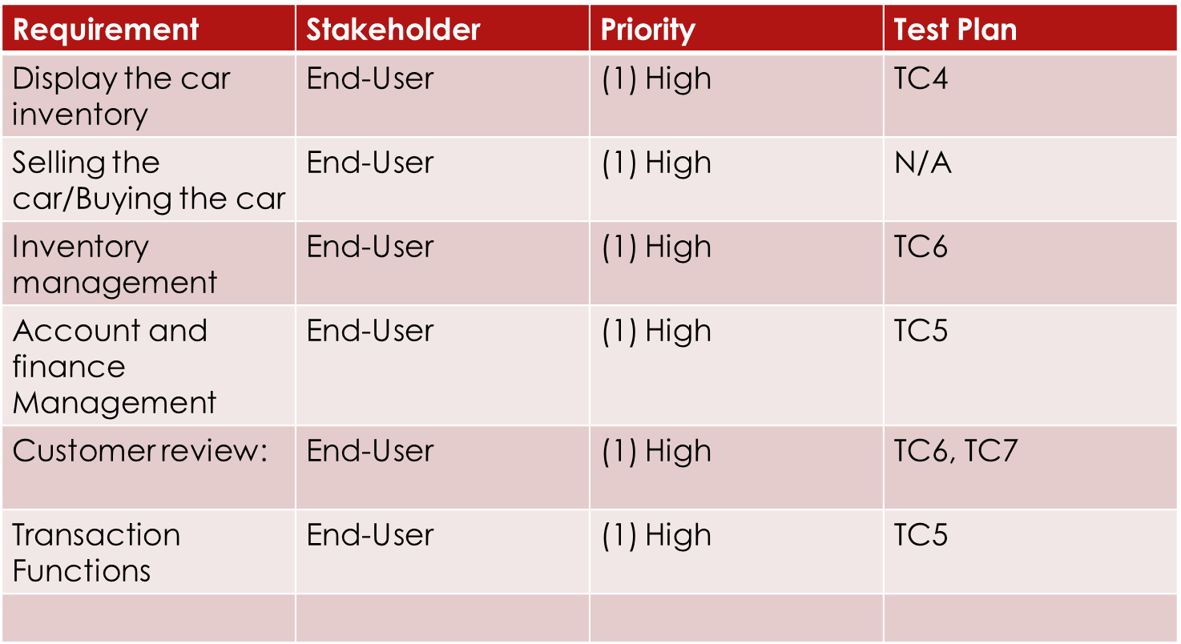

1. **Display the car inventory:**

* There must be a separate and easy to access tab to show all available cars at the dealership.
* The information accessed must be kept in a distinct and secure database to ensure maximum data availability.

1. **Selling/Buying the car:**

* Both the seller and the buyer must have a user account in order to access the buy/sell feature.
* The system will provide both options as per the customer’s requirements.

1. **Inventory Management:**

* All the available sale items including cars, parts, accessories, and so on must be stored as different classes in a master database.

1. **Accounts and Finance Management:**

* A reliable financial calculator to be included in the system to manage the dealership’s accounts.
* There must be a tab that has access to all relevant financial details of a particular car through a unique search inquiry.

1. **Customer Review:**

* The system allows customers to give relevant reviews on products and services that allow the dealership to further improve.

1. **Transaction Functions:**

* The system includes the use of flawless and transparent payment methods and techniques for maximum reliability for both the dealers and the customers.

**4. External Interface Requirements**

**4.1 User Interfaces**

The User Interface is an essential part of any Software Application. It is a key element that links the application to the user by providing a smooth and easy to use platform.

The EazyCar Bazar consists of an interface that is being operated on a server that is capable enough to host numerous users at an instance. The application further makes use of graphical tools, Java development kits, and other relevant software tools to provide a smooth and swift user interface.

**4.2 Hardware Interfaces**

The EazyCar Bazar app is an Object-Oriented System. It has very specific and minimal Hardware requirements. The system is designed to run on both Linux and Windows OS. To ensure maximum performance, it is advised that the client at least has a system equipped with Windows 8 aided with 4gb RAM and 256gb hard drive.

**4.3 Software Interfaces**

EazyCar Bazar is application-based software. Its main purpose is to provide the clients/customers with an easy to use and interactive platform where they can get information regarding automobiles and other activities regarding the automobile industry, as already discussed in great detail. Keeping that in mind, the project has been designed for providing the best Software based Experience to the end user. Details of each Software interfaces are as follows:

1. **Programming Language:**

As far as the connections between the Software and the Hardware are concerned, this Educational Departmental Management Software is based on C++ language. The user will have a visual interaction available, coded on C++. The database consisting of the client’s information, the dealers and the inventory is stored in SQL Management Server.

1. **Operating Systems:**

To make it well timed and easy for an admin to use the application, it has been made compatible with Windows 7 and above Operating Systems. This will make it easy to use by the actor. The application along with running on Windows is compatible with different interfaces and operating systems such as Linux so that there are no hurdles in using the application.

1. **Compatibility:**

To make sure the end user gets the best possible experience, the system has been designed in a 32-bit format, also known as an x32 software. This allows the software to be run smoothly on any computer whether it has a 32-bit or a 64-bit processor. This also eliminates any backlashes due to Operating Systems that might be x64 or x86 compatible. An x32 Software will run smoothly on both types of Operating Systems.

**4.4 Communication Interfaces**

Following are the communication functions required for communication with the Server and sending and receiving SMS through GSM device.

* Server is required to send and receive E-mails from the Internet.
* Windows Server 2006 should be installed on Server to get fast and accurate data transfer.
* The security issues in Internet E-mail include secrecy, content integrity, and identity integrity.

1. **Other Non-functional Requirements**

## **Performance Requirements**

* In case of a sudden crash the software should be able to save the data being processed.
* The application ought to have data backup.
* The software ought to work while the system is online and should be able to facilitate to large amount of data as needed by the user.
* The software ought to be able to support windows seven and on top versions.
* It must not crash or damage the applications that are being used beside the software.

## **Safety Requirements**

* The application will be created to facilitate the data of the clients, dealers, administrators and the rest of the actors (visitors, etc) involved
* It is considered highly sensitive and personal, therefore proper checks ought to be placed to ensure that there is no loss of data.
* Due to transactions being made it would be essential to have proper safety checks to prevent leaking of important information

## **Security Requirements**

* Using of any software that is not well protected such as Microsoft Access database may be a risk to security.
* Files generated by such software’s are not protected by any kind of mechanism and therefore pose a risk to the security.
* Necessity to confirm that the software system being used is not at risk of any vulnerability and is well protected.

## **Software Quality Attributes**

* The application is not controlled by any kind of network.
* It is versatile to use
* The software is lightweight and does not disturb the speed of the machine.
* The software and its modules are reusable and may be modified to enhance or customize the application in the maintenance phase.

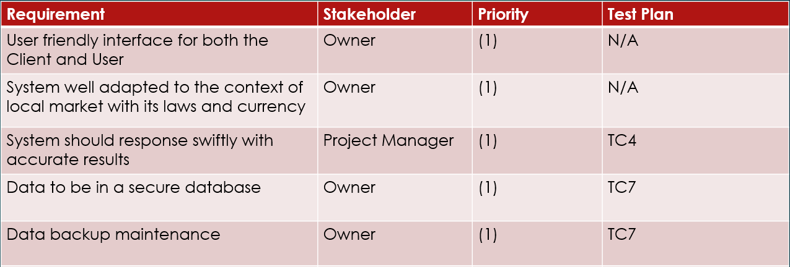

1. **Feasibility Study**

Feasibility study is the feasibility analysis or it is a measure of the software product in terms of how much beneficial product development will be for the organization in a practical point of view. Feasibility study is carried out based on many purposes to analyze whether software product will be right in terms of development, implantation, contribution of project to the organization etc.

**6.1 Financial Feasibility**

* Being a web application there will be an associated hosting cost.
* Bug fixing and maintaining tasks will have a customary cost.
* Additional costs related to hardware and development tools if required.
* The estimated cost of the overall project is expected to be around PKR 1.5 million.
* Looking at the above-mentioned pointers, the application seems financially feasible.

**6.2 Operational Feasibility**

* The presence of such an effective application automatically reduces unnecessary labor.
* In turn there is a definite increase in skill labor that will adapt to the system and deal with any management or institutional difficult.
* The application has a user-friendly interface that makes it easy and smooth to operate.
* These characteristics make the application operationally feasible.

**6.3 Legal/Government Feasibility**

* EazyCar Bazaar uses freely available development tools and provides the system as an open source system.
* Periodic maintenance cost is charged from the client when required with authentic documentation and verification within legal boundaries.
* Software libraries used in this application are free open source libraries.
* However, the proposed system will be unique and protected for the owner. Furthermore, the application can be imitated as a format under patency laws
* Since, the application performs functions within the legal boundaries of the government, it is legally feasible.

**6.4 Technological Feasibility**

* The main technological tools associated with this web application are:

1. HTML
2. CSS
3. JSP
4. MySQL
5. JS
6. NetBeans
7. Diagram drawing tools such as Visio

* Each of these technologies is easily available and the required technical skills are manageable.
* The website would initially be hosted in a free web hosting space which would later be hosted in a paid web hosting space.
* From these it’s clear that the web application is technically feasible.
  1. **Scheduling Feasibility**

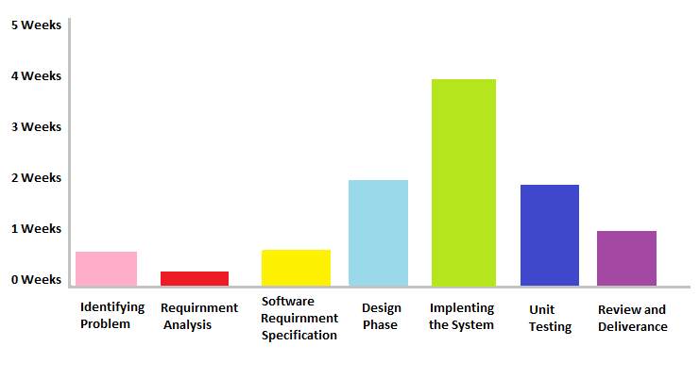

1. **UML DIAGRAMS**

**7.1 USE CASE**

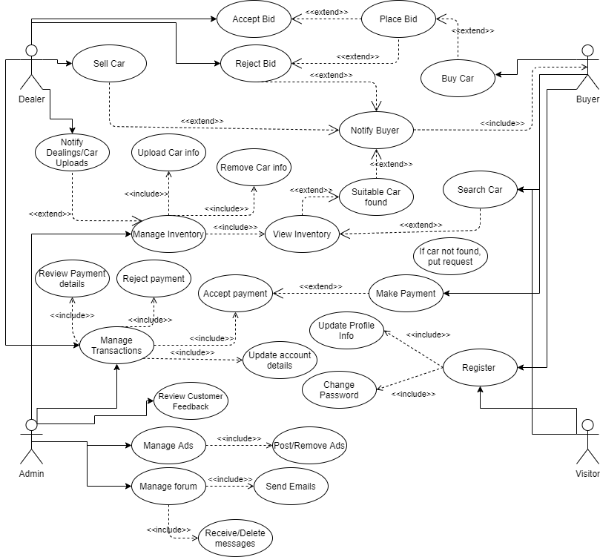

**7.2 ACTIVITY DIAGRAMS**

**Customer Activity Diagram**

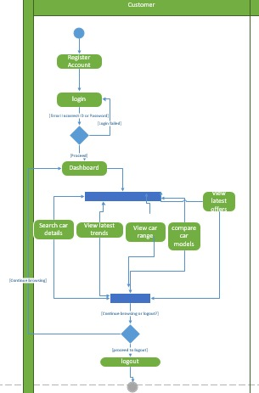

**Dealer Activity Diagram**

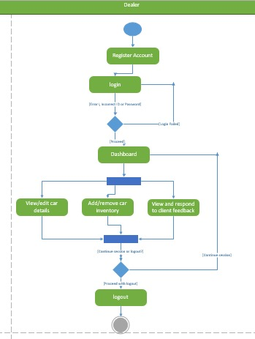

* 1. **CLASS DIAGRAM**

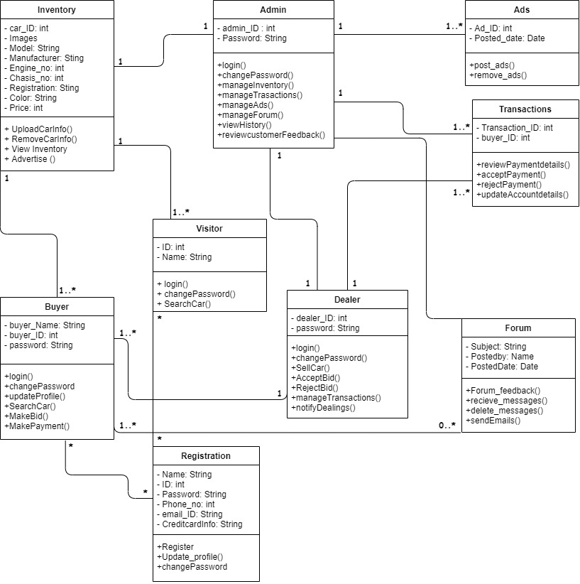

**7.4 SEQUENCE DIAGRAM**

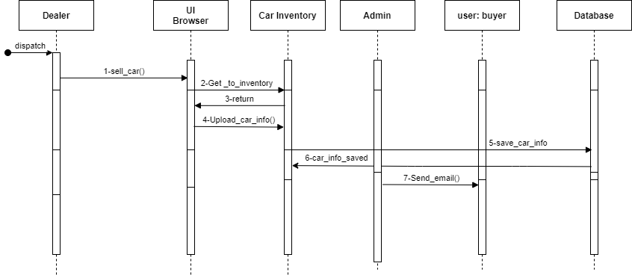

**Dealer Sequence Diagram**

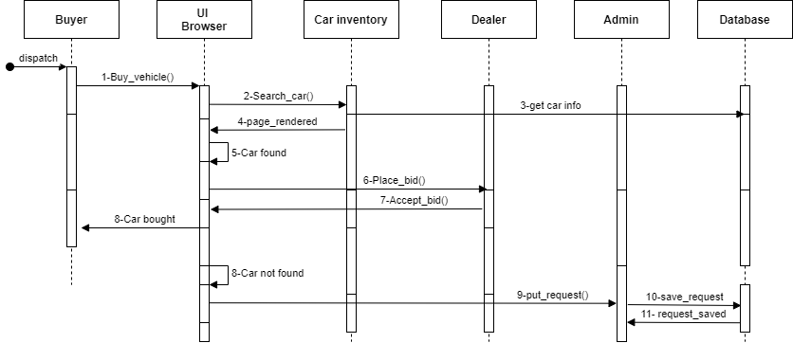

**Buyer sequence diagram**

1. **REQUIREMENT TRACEABILITY MATRIX (RTM)**

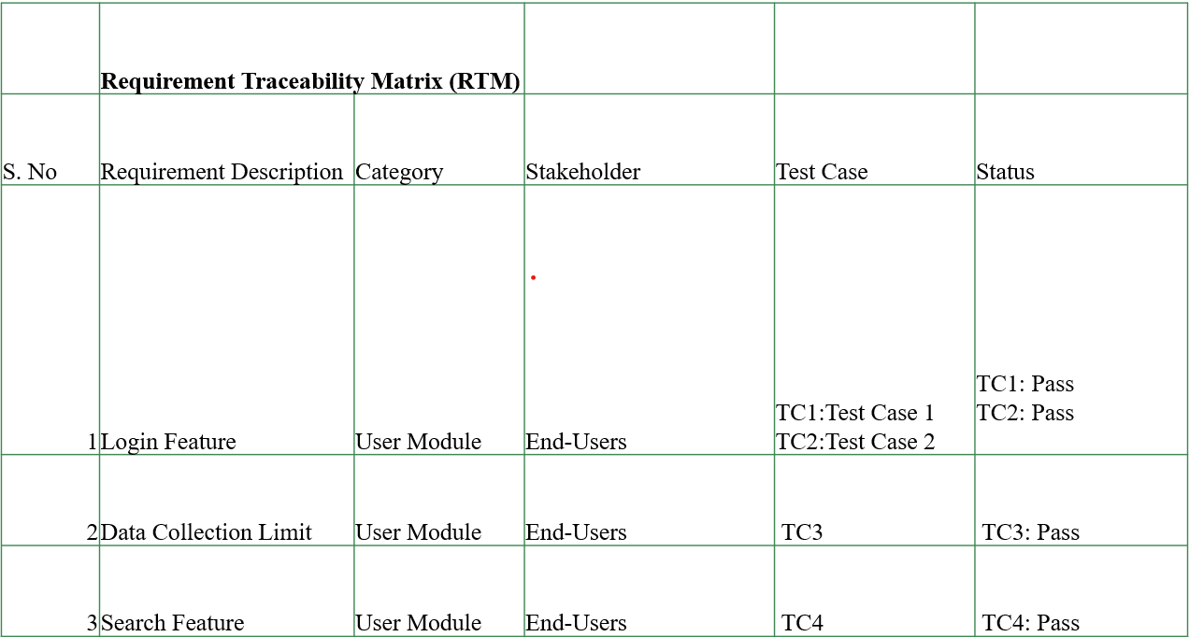

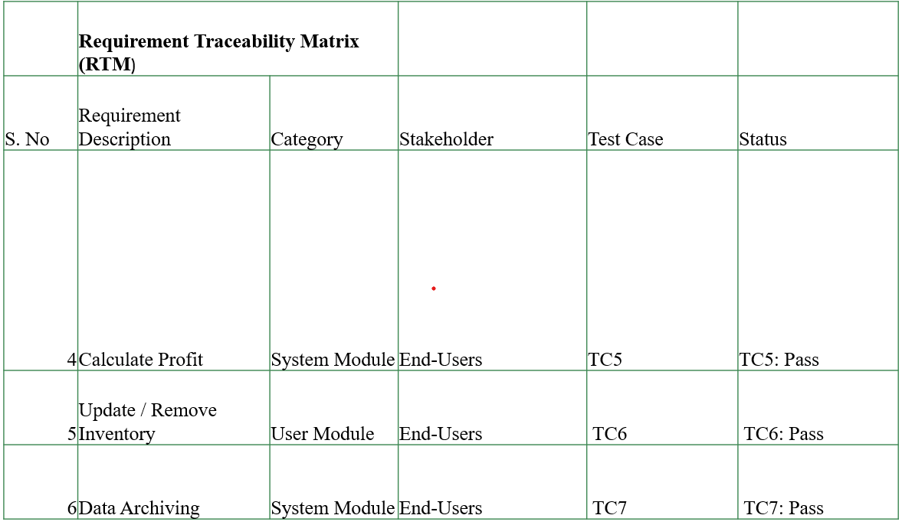

1. **TEST CASES**

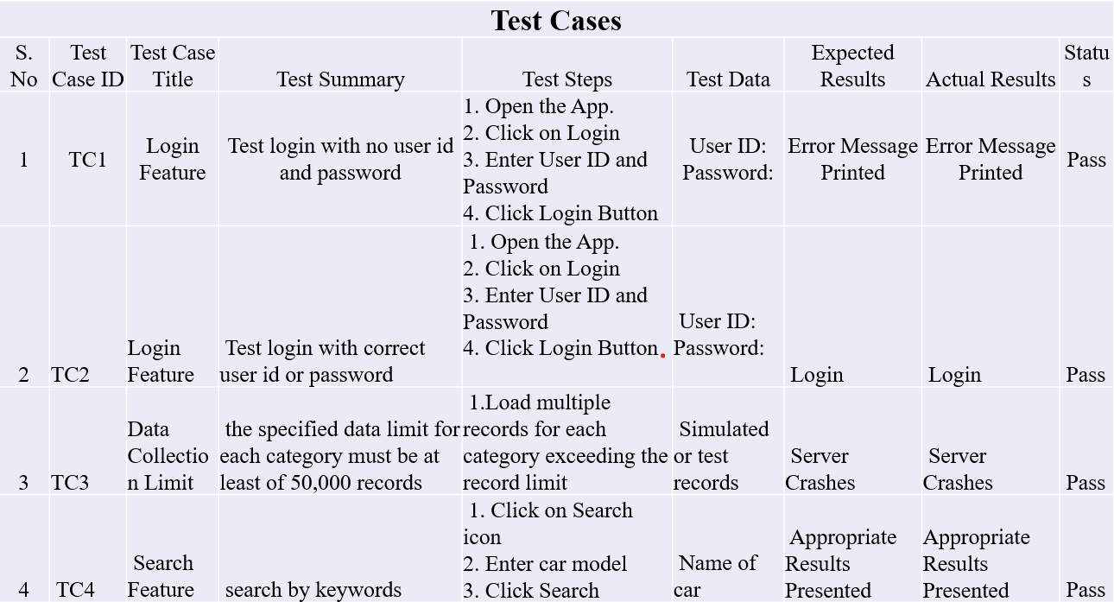

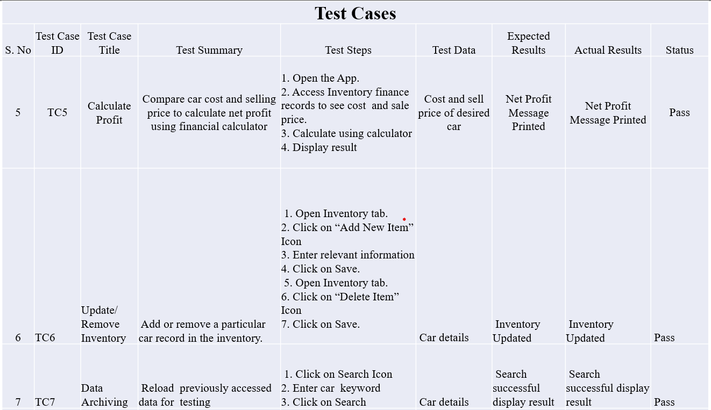

1. **GANTT CHART**

